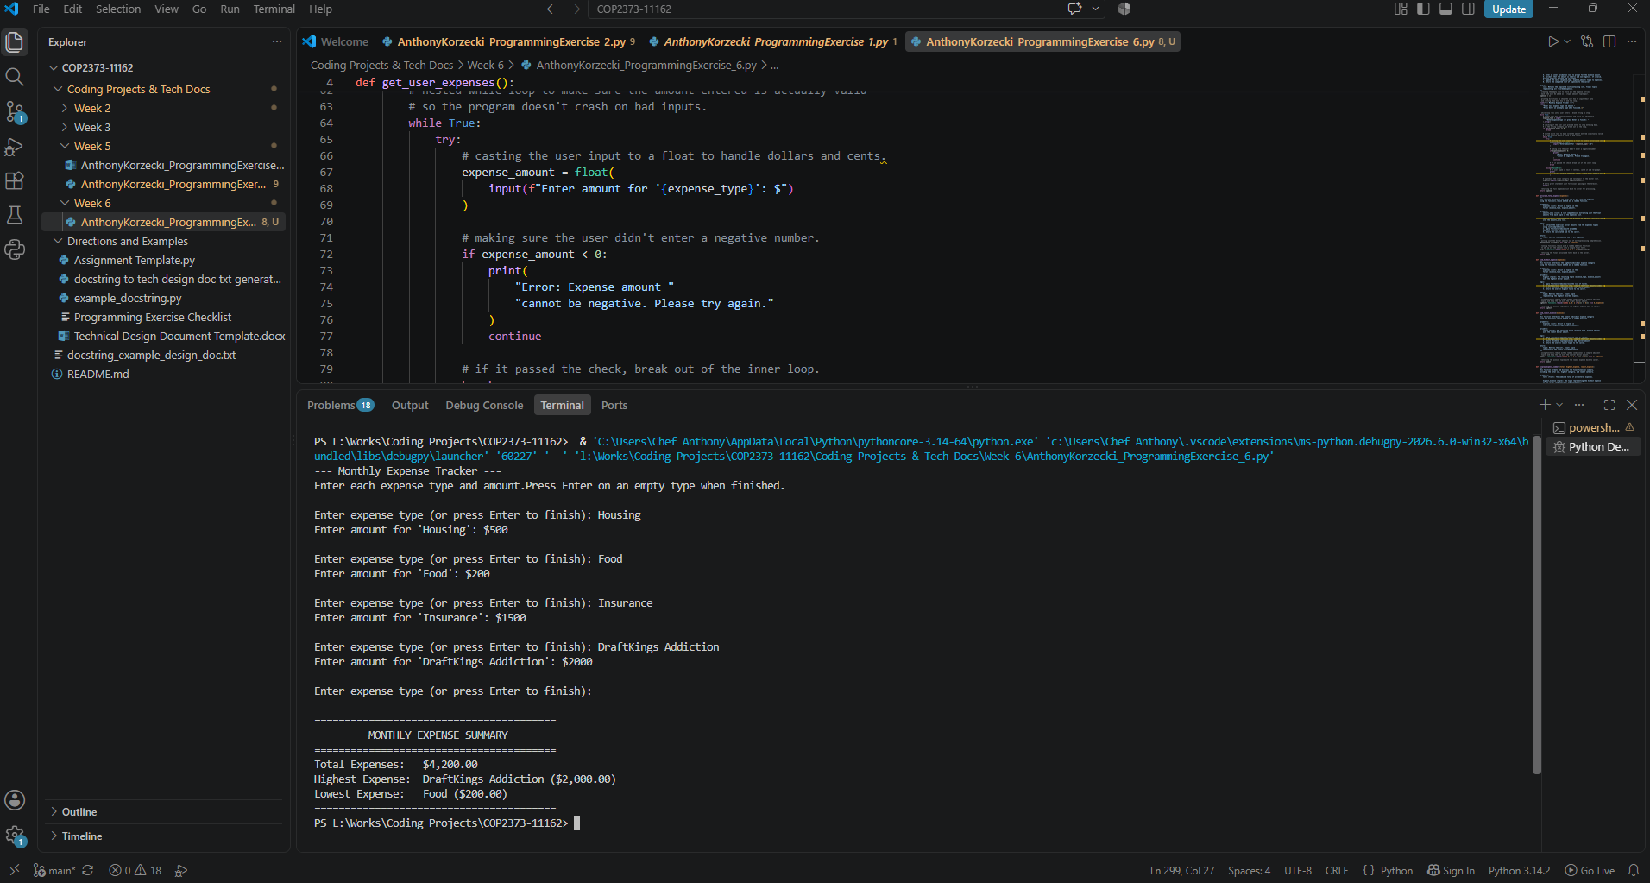
# Technical Design Document: AnthonyKorzecki_ProgrammingExercise_6

# Name: Anthony Korzecki
# Date: September 27, 2026
# Program Description: This program is an interactive Python application that collects a list of monthly expenses and their dollar amounts from the user until an empty entry is submitted. It uses the functools.reduce method alongside lambda functions to calculate the overall total expenditure and identify the highest and lowest spending categories. Finally, it outputs a formatted summary to the console that clearly displays the total cost along with the labels and amounts for both the maximum and minimum expense

## Function: calculate_total_expense
This function calculates the total sum of all recorded expenses
using the functools.reduce method and a lambda function.

Parameters:
expenses (list): A list of tuples in the
format (expense_type, expense_amount).

Variables:
amounts_only (list): A list comprehension extracting just the float
amounts from each tuple in the expenses list.

total (float): The accumulated sum produced by applying functools.reduce
over the amounts_only list.

Logic:
1. Extract the numerical dollar amounts from the expenses tuples
using list comprehension.
2. Apply functools.reduce with a lambda
addition function across the list.
3. Return the calculated sum to the caller.

Return:
float: Returns the combined sum of all expenses.

## Function: display_expense_summary
This function formats and displays the final financial summary,
including the total sum, highest category, and lowest category.

Parameters:
total (float): The combined total of all entered expenses.

highest_expense (tuple): The tuple representing the highest expense
in the format (expense_type, expense_amount).

lowest_expense (tuple): The tuple representing the lowest expense
in the format (expense_type, expense_amount).

Variables:
None

Logic:
1. Print decorative delimiter headers for output formatting.
2. Print formatted total expense with 2 decimal precision.
3. Print formatted highest expense label and dollar amount.
4. Print formatted lowest expense label and dollar amount.
5. Print closing delimiter.

Return:
None

## Function: find_highest_expense
This function determines the highest individual expense category
using the functools.reduce method and a lambda function.

Parameters:
expenses (list): A list of tuples in the
format (expense_type, expense_amount).

Variables:
highest (tuple): The resulting tuple (expense_type, expense_amount)
with the highest dollar amount.

Logic:
1. Apply functools.reduce across the list of tuples.
2. In each pairwise reduction step, compare the float amounts (index 1).
3. Return whichever tuple possesses the greater amount.
4. Return the overall highest tuple to the caller.

Return:
tuple: Returns the (str, float) tuple
representing the highest recorded expense.

## Function: find_lowest_expense
This function determines the lowest individual expense category
using the functools.reduce method and a lambda function.

Parameters:
expenses (list): A list of tuples in
the format (expense_type, expense_amount).

Variables:
lowest (tuple): The resulting tuple (expense_type, expense_amount)
with the lowest dollar amount.

Logic:
1. Apply functools.reduce across the list of tuples.
2. In each pairwise reduction step, compare the float amounts (index 1).
3. Return whichever tuple possesses the smaller amount.
4. Return the overall lowest tuple to the caller.

Return:
tuple: Returns the (str, float) tuple
representing the lowest recorded expense.

## Function: get_user_expenses
This function gathers monthly expenses from the user by repeatedly
prompting for an expense type and its corresponding dollar amount until
an empty input is provided.

Parameters:
None

Variables:
expenses (list): A list of tuples storing each entry in the format
(expense_type, expense_amount).

expense_type (str): The label or name of the expense entered by the
user. Serves as a sentinel to stop input collection when left blank.

expense_amount (float): The validated dollar value associated with
the current expense type.

Logic:
1. Initialize an empty list named expenses to store the entries.
2. Enter an indefinite while loop to gather user input.
3. Prompt the user for the expense category/type.
4. Check if the input is empty; if so, break out of the collection loop.
5. Enter an inner validation loop to prompt for the expense amount.
6. Validate that the amount is numeric and non-negative. If invalid,
display an error message and re-prompt.
7. Append the valid (expense_type, expense_amount) tuple to expenses.
8. Return the completed list of expenses to the caller.

Return:
list: Returns the populated list containing (str, float) tuples
representing all recorded expenses.

## Function: main
This is the primary driver function that coordinates data collection,
analysis calculations, validation checks, and presentation of results.

Parameters:
None

Variables:
user_expenses (list): Stores the collection of expense tuples returned
from the input gathering function.

total_spent (float): Stores the aggregated total calculated by
the reduction function.

highest_record (tuple): Stores the tuple containing the highest category
and value.

lowest_record (tuple): Stores the tuple containing the lowest category
and value.

Logic:
1. Call get_user_expenses to populate user_expenses.
2. Check if the list contains any items. If empty, print an alert
and terminate execution.
3. Call calculate_total_expense to compute aggregate expenditure.
4. Call find_highest_expense to determine the top expense tuple.
5. Call find_lowest_expense to determine the lowest expense tuple.
6. Pass the results to display_expense_summary to print the final report.

Return:
None

#Link to your repository: https://github.com/akorzecki/COP2373-11162

